Student’s name | …………………………………………………….…… | Grade | 1
Subject | Computer | Week No. | 3
Lesson Title | Need of Computers | Unit
Worksheet No. ( 3 )

write the correct name of each part
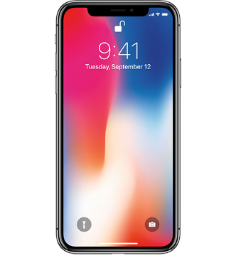

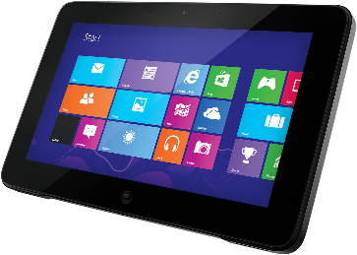
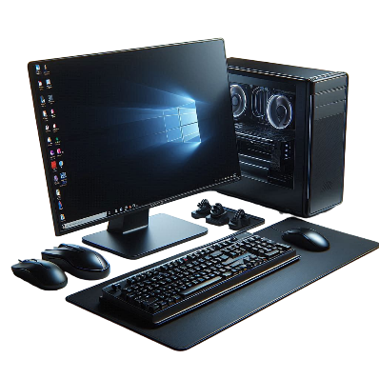
Phone
Laptop
Computer
Tablet
Laptop
Tablet
Good Luck

Computer
Phone

